IPL 2025 SQL Queries

1. SELECT * FROM IPLPlayers

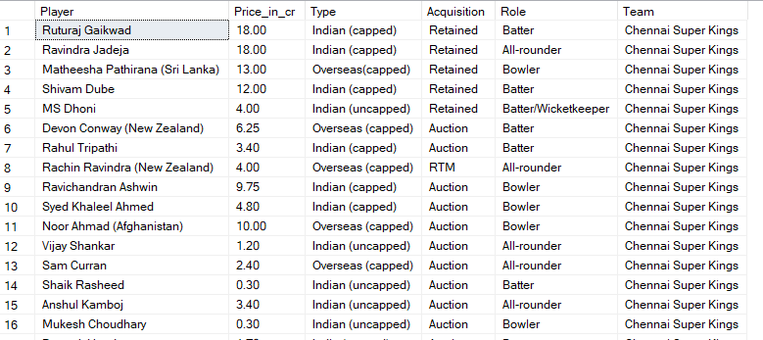

By the above query we have checked the database details.

**Q2)** Find the total spending for each Team?

SELECT Team, SUM(Price_in_cr) as Total_Spending

FROM IPLPlayers

GROUP BY Team

ORDER BY Total_Spending DESC;

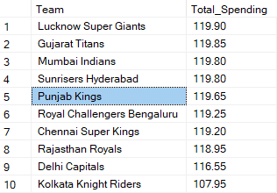

**Q3)** Find the top 3 highest paid "All-rounders" across all the team?

SELECT TOP 3 Player, Team, Price_in_cr

FROM IPLPlayers

WHERE Role = 'All-rounder'

Order by Price_in_cr DESC;

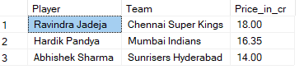

Q4) Find the highest price player in each team?

With CTE AS(

SELECT Team,Max(Price_in_cr) as Highest_Price

FROM IPLPlayers

GROUP BY Team)

SELECT I.Player,C.Team,C.Highest_Price

FROM IPLPlayers I

LEFT JOIN CTE C

ON I.Team=C.Team

WHERE I.Price_in_cr=C.Highest_Price;

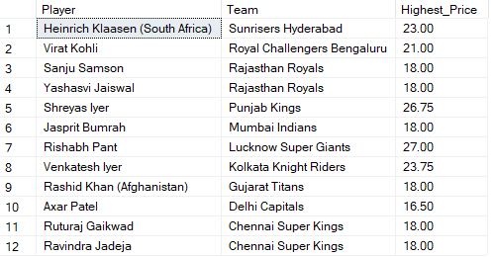

Q5) Rank the Players by their Price within each team and list the top 2 from every team?

WITH CTE AS

(Select Player,Team,Price_in_cr,

ROW_NUMBER () OVER (PARTITION BY Team ORDER BY Price_in_cr DESC) as Rank

FROM IPLPlayers)

SELECT Player,Team,Price_in_cr, Rank

FROM CTE

WHERE Rank<=2;

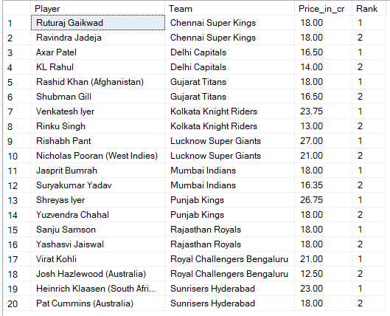

Q6) Calculate the Percentage Contribution of each player's price to their team total spending ?

SELECT Player,Team,Price_in_cr,

CAST(Price_in_cr/(SUM(Price_in_cr) OVER (PARTITION BY Team ))*100 AS DECIMAL(10,2)) as Contribution_percentage

FROM IPLPlayers;

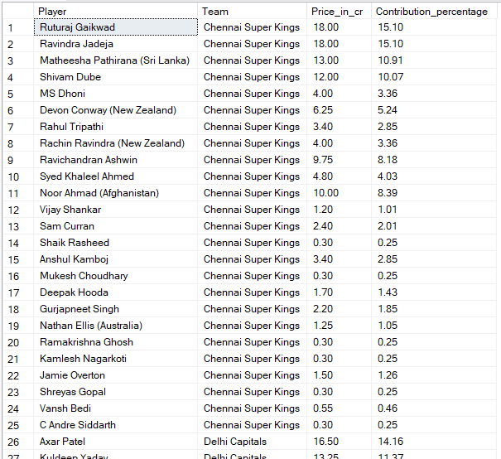

Q7) Classify players as 'High','Medium' or 'Low' priced based on following rules:

High: Price >15 cr

Medium: Price between 5 cr and 15 cr

Low: Price<5 cr and find out the players in each bracket.

With cte as(

SELECT Player, Team, Price_in_cr,

CASE

WHEN Price_in_cr >15 THEN 'High'

WHEN Price_in_cr BETWEEN 5 AND 15 THEN 'Medium'

ELSE'Low'

END AS Classification

FROM IPLPlayers)

SELECT Team,Classification,COUNT(*) AS NoOfPlayers

FROM CTE

GROUP BY Team, Classification

ORDER BY Team, Classification;

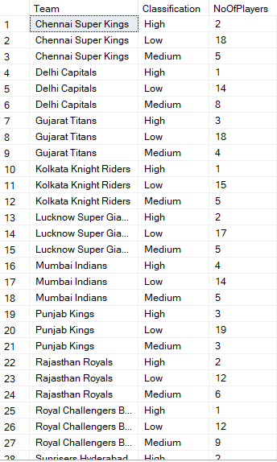

Q8) Find the average price of Indian Players and compare it with overseas players?

SELECT 'Indian' as PlayerType,

(SELECT AVG(Price_in_cr) FROM IPLPlayers

WHERE Type LIKE'Indian%') AS Avg_Price

UNION ALL

SELECT 'Overseas' as PlayerType,

(SELECT AVG(Price_in_cr) AS Avg_Price FROM IPLPlayers

WHERE Type LIKE'Overseas%' ) as Avg_Price

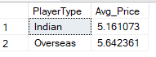

Q9) Identify players who earn more than the average price in their team?

SELECT Player, Team, Price_in_cr

FROM IPLPlayers as p

WHERE Price_in_cr>

(

SELECT AVG(Price_in_cr) FROM IPLPlayers

WHERE Team=p.Team)

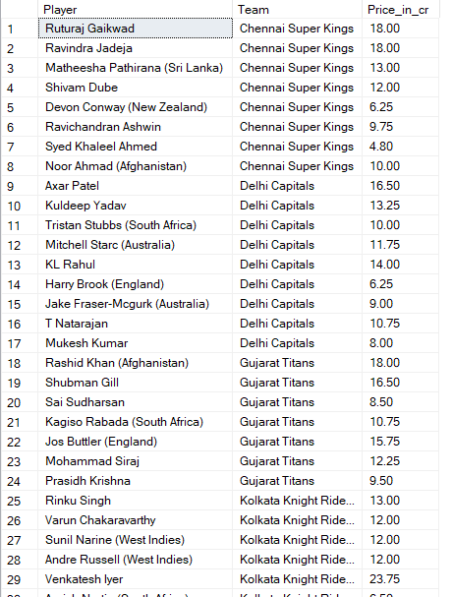

Q10) For each role, find the most expensive player and their price using a correlated subquery?

SELECT Player, Team, Role, Price_in_cr

FROM IPLPlayers as P

WHERE Price_in_cr =

(SELECT MAX(Price_in_cr)

FROM IPLPlayers

WHERE Role =P.Role)

